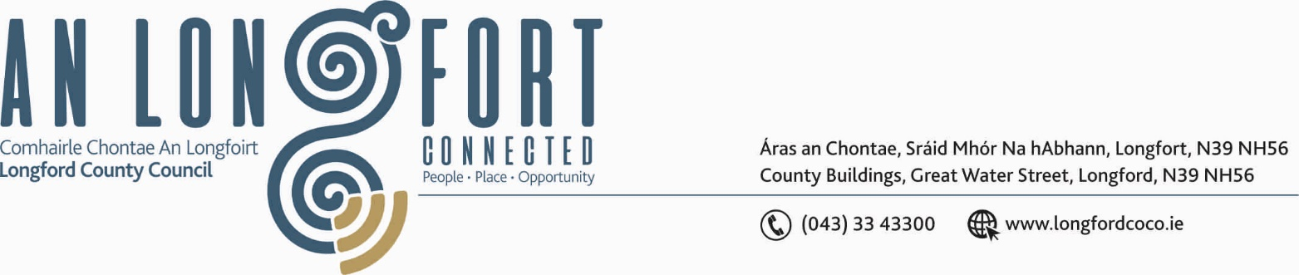

GRANARD MUNICIPAL DISTRICT

Please note Venue of Meeting – Aras an Chontae.

10th October 2019.

To: Each Member of Granard Municipal District.

A Chomhairleoir,

You are requested to attend Meeting of Granard Municipal District to be held in the
Council Chamber, Aras an Chontae, Longford on Tuesday, 22nd October 2019 at
3.00 p.m. to consider the 2020 General Municipal Allocation

Mise le meas,
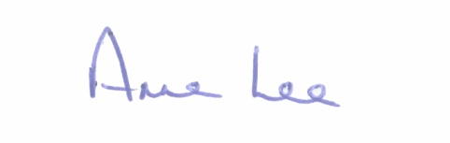

________________
Anne Lee,
Meetings Administrator.



